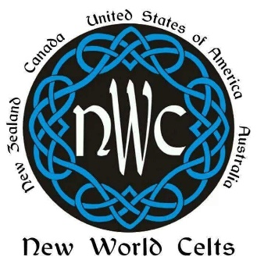
Individual Sponsorship
Application
The New World Celts Organization wishes to reward the talents of people who have demonstrated an interest in learning and promoting Celtic culture and heritage. To aid people in their endeavors to support this mission, the New World Celts are offering sponsorships to assist with the costs associated with participating in the Celtic arts. Sponsorships awarded to individuals and will not exceed the amount of $500 per application.
Local Chapter: ___ Charlotte ___Bradenton ___Brandon ___Dunedin ___Orlando ___Venice ___Volusia
PLEASE PRINT CLEARLY
Name: ________________________________________________________ Amount Requested: _______________
Address: _________________________________________________________________________________________
City: ________________________________________________ State: ________________ Zip: _________________
Phone: ______________________________________ Email: _____________________________________________
Please include on a separate page a personal statement containing the following information:
•A description of the proposed activity including the actual cost of the activity and clear evidence that it relates to the goals of learning and promoting Celtic culture and heritage.
•A personal statement of intent describing why you want to be involved in this activity and how you intend to benefit from such activity as it promotes your own Celtic understanding and awareness. If the applicant is not a member of a New World Celts Chapter, a letter of recommendation from a member of a New World Celts Chapter or other individual involved in an organization with Celtic related interests must accompany the application.
I certify that the information given in this application is true and correct to the best of my knowledge. The New World Celts Sponsorship Committee or their duly appointed representatives have my permission to perform inquiries as necessary to validate the information I have presented in this application.
Signature _______________________________________________ Date _____________________
Return all sponsorship applications to the address listed on the website for the chapter with which you are applying.

